**Microprocessor Systems Lab**

**Project Report**

**EE222-L**



**Wisal Khan Khattak 2018510**

**Zahid Ullah Khan 2018513**

Contents

1. Abstract …………………………………………………………………………………… Page 3
2. Introduction ………………………………………………………………………………. Page 3
3. Components ……………………………………………………………………………… Page 3
4. Useful Examples ………………………………………………………………………… Page 3
5. Design And Working …………………………………………………………………… Page 3
6. Working Of LDR …………………………………………………………………………. Page 3
7. Working Of Smoke Sensor ……………………………………………………………. Page 4
8. Proteus Design ………………………………………………………………………….. Page 4
9. Software Details ………………………………………………………………………… Page 1
10. Results ……………………………………………………………………………………. Page 1
11. Conclusion ………………………………………………………………………………. Page 1
12. References ………………………………………………………………………………. Page 1

Light(LDR) and Smoke Detectors

Wisal Khan Khattak (2018510) EEE

***Abstract:***

For making the sensors we have took advantage of the PIC18f4550 microcontroller, further we configured the different pins for taking the inputs and giving the outputs.

# 1)Introduction

Light dependent resistors, LDRs or photoresistors are often used in circuits where it is necessary to detect the presence or the level of light .They can be described by a variety of names from light dependent resistor, LDR, photoresistor, or even photo cell, photocell or photoconductor. Although other devices such as photodiodes or photo-transistor can also be used, LDRs or photoresistors are a particularly convenient electronics component to use. They provide large change in resistance for changes in light level. A smoke detector is an electronic fire-protection device that automatically senses the presence of smoke, as a key indication of fire, and sounds a warning to building occupants. Household smoke detectors, or smoke alarms, issue an audible and/or visual alarm locally from the detector itself. They can be battery-powered single units or several interlinked hardwired (mains-powered) devices backed up by batteries. The latter must be installed in all new buildings and after major refurbishments.

# 2) COMPONENTS

* Pic18f4550
* Resistor 10k
* Push Button
* Torch LDR
* Power
* Speaker/Buzzer

Zahid Ullah Khan (2018513)  
EEE

## 3) USEFUL EXAMPLES

This security system is very useful in our day to day lives as it allows to keep ourselves safe from fire or higher/lower voltages . It can be used in many places as this security system can be used as efficient kitchens which will enable our houses , hotels and other intitutions to be safe, in the case of light detector it can offer us the previlege of softaware where we can easily enter our doors without any physical touching and can serve as a huge advantage for physically disabeled people. Furtheron this security system can also put itself to use in projects that are required to worrk only in daylight and needs to be stopped in the night or dark .

4)DESIGN AND WORKING

The light and smoke detecting system constitutes both hardware and software. The software of the security system can be categorised as the programming in MPlab software whereas the hardware system can be designed using the specified components.

1. THE WORKING OF LDR

The circuit is configured through the code burnt into the pic18f4550.The LDR is connected through the pin RA0 with a 10k resistor. Whenever a light is brought near the light dependent resistor, a pulse of voltage is produced which is then divided by voltage divider rule with 10k resistor so, whenever the voltage is in between certain range i.e 300-800V the LED connected at pin RC1 is switched off, beyond these ranges the green LED will be switched on.

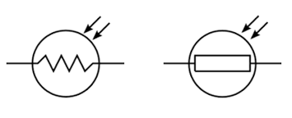

Figure 1 : LDR (Light Dependent Resistor)

Figure 1 : LDR (Light Dependent Resistor)

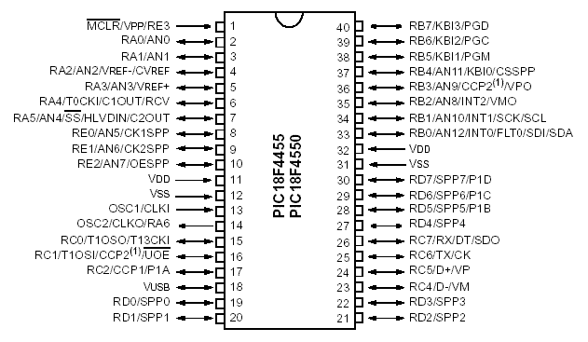

Figure 2 : PIC18F4550

B) WORKING OF SMOKE SENSOR

The working of smoke sensor is quite simple, whenever an input is given at pin RB7 which is either 1 or 0 through the button, a sound is generated at the buzzer or sounder which basically indicates the presence of smoke nearby . As we do not have a separate sensor for smoke in the proteus so we just put a bush button instead of it . It acts the same way as if a high voltage is detected by the system via push button.

C) DESIGN OF THE CIRCUIT

For the design portion of the circuit we have used proteus software where we can simply place all these components easily and can stimulate our design easily for errors. As we do not have a separate smoke sensor like the LDR in our proteus , we used a single push button for the detection purpose of the smoke. And placed a sound system for alarming us if there is any smoke detected . Figure 3 contains the circuit of our design prepared via Proteus. We used torch LDR for the light detector in our proteus design whose output is always an analogue that is why we connected it with the AN0 pin of the PIC18F4550. Now if we change the intensity of the torch , we will see the value of the voltages on our LCD . We have specified oour code to give output at a GREEN LED only when a certain range of light intensity is detected.

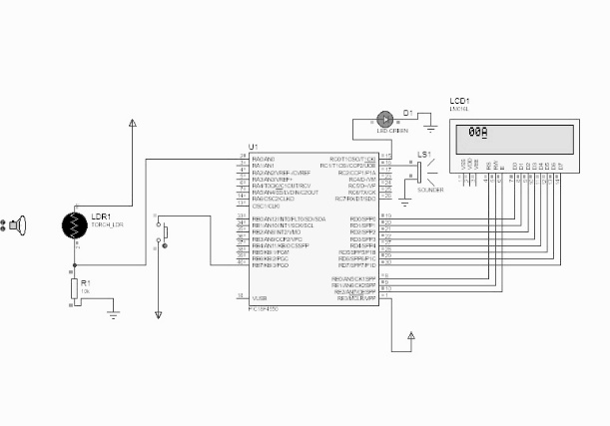

Figure 3 : CIRCUIT DESIGN

## 4) SOFTWARE DETAILS

This system has a very complicated software logic and we used Mplab software to write abd build the code for this project . We used a lot of basic instrustion codes in this project as they can serve our purpose well . Below are the screenshots of our code we programmed .

Figure 4 : 1st Page of Code

Figure 5 : 2nd Page of Code

Figure 6 : 3rd Page of Code

Figure 7 : 4th Page of Code

Figure 8 : 5th Page of Code

5) RESULTS

We have simulated and burned our code on the proteus design and it worked perfectly. First of all the smoke detector worked correctly and without any delay or error we were alarmed at the exact time . The LDR portion is quit interesting and we checked different values of intensities on our torch LDR and got our desired values on our LCD screen and aslo the green led which indicated the range we specified for our system .

Figure 9 : Results shown on LCD

## 6) CONCLUSION

The LDR and Smoke detecting system is very effiecient in our day to day lives and can greatly change the overall perspective of safety of lives and property. A lot of deaths are caused due to fire in this compact living and causes much more pollution in our Eco-system but if we use devices like these which can detect smoke and can turn on some water system and also inform the near by people by alarm , great results can be achieved . Furtheron it is not also much expensive to install and function and maintenance cost is nearly negligeble to consider. It is not much difficult to install but only requires a few steps which can greatlly change our lives.

# 7)References

1. <https://www.wikinote.org/course/view.php?id=5>
2. <https://www.youtube.com/>
3. <https://www.ifsecglobal.com/smoke-detectors/>
4. <https://www.electronics-notes.com/articles/electronic_components/resistors/light-dependent-resistor-ldr.php>